Noun Phrase Subject

✅ What is Noun Phrase Subject
# Source: AI Source: Provided by: [Data Path: Persons Table -> ID Column: 1, Name_En Column: Motasem Essam] -> From: [Chatgpt (GPT-4-turbo)] on [8/4/2025]
A noun phrase subject is a group of words centered around a noun that functions as the subject of the sentence. It includes the main noun (head) and all its modifiers.

🔹 Key Features:
# Source: AI Source: Provided by: [Data Path: Persons Table -> ID Column: 1, Name_En Column: Motasem Essam] -> From: [Chatgpt (GPT-4-turbo)] on [8/4/2025]
- Functions as the subject of the sentence.
- Includes determiners, adjectives, prepositional phrases, and other modifiers along with the head noun.
- The verb agrees with the head noun in number.

🔹 Examples:
# Source: AI Source: Provided by: [Data Path: Persons Table -> ID Column: 1, Name_En Column: Motasem Essam] -> From: [Chatgpt (GPT-4-turbo)] on [8/4/2025]
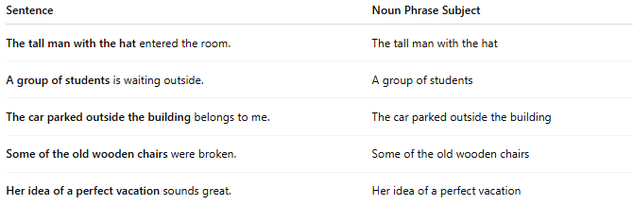
Sentence | Noun Phrase Subject
The tall man with the hat entered the room. | The tall man with the hat
A group of students is waiting outside. | A group of students
The car parked outside the building belongs to me. | The car parked outside the building
Some of the old wooden chairs were broken. | Some of the old wooden chairs
Her idea of a perfect vacation sounds great. | Her idea of a perfect vacation

🔍 Structure of a Noun Phrase Subject:
# Source: AI Source: Provided by: [Data Path: Persons Table -> ID Column: 1, Name_En Column: Motasem Essam] -> From: [Chatgpt (GPT-4-turbo)] on [8/4/2025]
[Determiner] + [Modifiers] + [Head Noun] + [Postmodifiers]
Example:
The (det) + very old (modifiers) + book (head noun) + on the shelf (postmodifier)
→ "The very old book on the shelf" is a noun phrase subject.

